Evidence for first line use of an Angiotensin Receptor Blocker (ARB) instead of an Angiotensin Converting Enzyme (ACE) inhibitor in the treatment of adult hypertensive patients where the use of an ARB or ACE inhibitor is deemed equally appropriate
March 2022
Lucy Alexakis, Medicines Optimisation Pharmacist, Surrey Heartlands CCG
Supporting author Helen Garrood, Medicines Optimisation Pharmacist, Surrey Heartlands CCG
Executive Summary
NICE NG136 Hypertension in adult’s guideline (2019, last updated March 2022) and NICE NG203 Chronic kidney disease guideline (2021) both now give equal status of choice in their treatment pathways for an ACE inhibitor and an ARB, where clinically indicated. Evidence from research and reviews of clinical literature has mainly shown that effectiveness of ACE inhibitors and ARBs is similar, but ARBs show a better safety and tolerability profile.

Below summarises the potential benefits and disadvantages of recommending an ARB first line (over an ACE inhibitor) within our local hypertension guidelines.

Potential Benefits
- Decreased clinician appointments required for switching an ACE inhibitor to an ARB (if ACE inhibitor not tolerated)
- Decreased drug waste due to potential switching from ACE inhibitor to ARB
- Decreased administration time involved in changing from an ACE inhibitor to an ARB (including resource expenditure on associated blood testing)
- Fewer titration steps (which would involve GP and administration time) to maximum dose for the ARB losartan than current first line preferred RAAS inhibitor, ramipril. Ref CKS NICE Hypertension
- All ARBs are now available generically (apart from azilsartan) and have subsequently decreased in price. Some ARBs are similarly priced to the ACE inhibitor, ramipril, which is currently the first line RAAS inhibitor in Surrey Heartlands.
- When indicated an ARB is the recommended choice over an ACE inhibitor for adults of Black African or African–Caribbean family origin
- Some systems are starting to recommend an ARB over an ACE inhibitor.
- Increased patient adherence to therapy due to the potential avoidance of an ACE related cough and the requirement to change treatment.

Potential Disadvantages
- Slight change in current clinical practice
- This recommendation does not apply to all patient cohorts e.g., those diagnosed with heart failure or post MI patients.

The committee is asked to agree:

- Recommending an ARB over an ACE where they have been given equal status of choice for treating hypertension in adults.
- Agree on the first line ARB for treating hypertension in adults to be either:
- losartan or
- candesartan or
- a choice of either losartan or candesartan.
Introduction
The purpose of this review is to consider the updated NICE guidelines for hypertension in adults first published in 2019 (updated in March 2022) and to propose that where an ACE inhibitor and an ARB are given equal status of choice in a treatment pathway, that an ARB is initiated first line. The second part of the review is to consider which ARB would be recommended as a first line choice. The choice of ARB is an update of a previous 2014 Hypertension Treatment Guideline on the Surrey PAD, where losartan, candesartan and irbesartan are the recommended choices if an ARB is indicated.
Hypertension Treatment Options - Guidelines -PCN April 2014.pdf (res-systems.net)

This review will focus mainly on ARBs in hypertension.
This work is currently feeding into the Guildford and Waverley Alliance planned care agenda.
NICE Guidelines
NICE guideline [NG136] Hypertension in adults: diagnosis and management. Published: 28 August 2019, updated March 2022 Recommendations | Hypertension in adults: diagnosis and management | Guidance | NICE (accessed 9/3/22).
The relevant sections for ACE inhibitors and ARBs treatment are highlighted below

Choosing antihypertensive drug treatment (for people with or without type 2 diabetes)

Step1 treatment

An ACE inhibitor or an ARB should be offered to adults starting step 1 antihypertensive treatment who:
- have type 2 diabetes and are of any age or family origin (for adults of Black African or African–Caribbean family origin, an angiotensin II receptor blocker (ARB), should be considered in preference to an angiotensin-converting enzyme (ACE) inhibitor)
- are aged under 55 but not of black African or African–Caribbean family origin.

NICE states also that:
Offer a calcium-channel blocker (CCB) to adults starting step 1 antihypertensive treatment who:
- are aged 55 or over and do not have type 2 diabetes or
- are of Black African or African–Caribbean family origin and do not have type 2 diabetes (of any age). [2019]
Step 2 treatment

If hypertension is not controlled in adults taking step 1 treatment of a CCB, one of the following drugs in addition to step 1 treatment should be offered:

- an ACE inhibitor or
- an ARB or
- a thiazide-like diuretic
NICE states also that:
If hypertension is not controlled in adults taking step 1 treatment of an ACE inhibitor or ARB, offer the choice of 1 of the following drugs in addition to step 1 treatment:
- a CCB or
- a thiazide-like diuretic.

Step 3 treatment

If hypertension is not controlled in adults taking step 2 treatment, a combination should be offered of:

- an ACE inhibitor or ARB and
- a CCB and
- a thiazide-like diuretic

The NICE committee agreed the recommended treatment options should be broadened to include the choice of an ACE inhibitor or an angiotensin II receptor blocker, because they are now cost equivalent, and the committee also agreed they are clinically equivalent.

Comment: Equal choice is now given for an ACE inhibitor or an ARB in the treatment of hypertension. An ARB is the preferred treatment to an ACE inhibitor for type 2 diabetic patients of Black African or African-Caribbean family origin.
If an ACE inhibitor is started and not tolerated this may need to be switched to an ARB. This guidance does not cover pregnant women with hypertension.

A further NICE clinical guideline supporting equivalent treatment choice status between ARBs and ACE inhibitors

NICE guideline [NG203]. Chronic kidney disease: assessment and management. Published: 25 August 2021 Last updated: 24 November 2021. Overview | Chronic kidney disease: assessment and management | Guidance | NICE

Highlighted below are the relevant sections of the guideline with respect to the equivalent treatment status of ACE inhibitors and ARBs

An angiotensin-receptor blocker (ARB) or an angiotensin-converting enzyme (ACE) inhibitor (titrated to the highest licensed dose that the person can tolerate) should be offered to adults, children and young people with CKD who have hypertension and an ACR over 30 mg/mmol (ACR category A3 or above).

For adults, children and young people with CKD and diabetes (type 1 or type 2) an ARB or an ACE inhibitor (titrated to the highest licensed dose that the person can tolerate) should be offered if ACR is 3 mg/mmol or more.

For adults, children, and young people with CKD but without diabetes:
An ARB or an ACE inhibitor (titrated to the highest licensed dose that they can tolerate) should be offered, if ACR is 70 mg/mmol or more

Pharmacotherapy for proteinuria and choice of antihypertensive agent
People without diabetes
The evidence showed that, compared with placebo, ACE inhibitors reduced the risk of end-stage renal disease in people without diabetes. ARBs did not show the same effect. However, the committee did not believe the evidence was sufficiently robust to show that ACE inhibitors were better than ARBs. In addition, for people with type 2 diabetes, ARBs did reduce the risk of end stage renal disease and heart failure. Based on the limitations of the evidence and the evidence available for people with type 2 diabetes, the committee recommended both ACE inhibitors and ARBs.

People with type 2 diabetes
For people with type 2 diabetes, ARBs reduced the risk of end-stage renal disease and heart failure. The committee also recommended ACE inhibitors because the evidence did not show a clear difference between ACE inhibitors and ARBs on the following outcomes:
• reduction of proteinuria
• end-stage renal disease
• all-cause mortality
• cardiovascular mortality
• non-fatal cardiovascular events
• adverse events (hypotension)
• hospitalisation.

Comment: ACE inhibitors and ARBs are recommended equally in the NICE NG203 Chronic Kidney Disease guidelines.

NICE guidelines where ARBs and ACE inhibitors are not given first line equivalent treatment choice status

NICE guideline [CG187] Acute heart failure: diagnosis and management. Published: 08 October 2014 Last updated: 17 November 2021. Overview | Acute heart failure: diagnosis and management | Guidance | NICE (accessed 9/3/22)
Recommends an ARB if there are intolerable side effects to an angiotensin-converting enzyme inhibitor (not given equal status).

NICE guideline [NG106] Published Chronic heart failure in adults: diagnosis and management. Published: 12 September 2018. Recommendations | Chronic heart failure in adults: diagnosis and management | Guidance | NICE (accessed 9/3/22)
Recommends an ARB if there are intolerable side effects to an angiotensin-converting enzyme inhibitor (not given equal status).
NICE guideline [NG185]. Acute coronary syndromes. Published: 18 November 2020. Overview | Acute coronary syndromes | Guidance | NICE (accessed 9/3/22)
After an MI, an ARB should be offered instead to people who are intolerant to ACE inhibitors (not given equal status).

Evidence

Comparative First-Line Effectiveness and Safety of ACE (Angiotensin-Converting Enzyme) Inhibitors and Angiotensin Receptor Blockers: A Multinational Cohort Study
RuiJun Chen, Marc A. Suchard, Harlan M. Krumholz, Martijn J. Schuemie, Steven Shea, Jon Duke, Nicole Pratt, Christian G. Reich, David Madigan, Seng Chan You, Patrick B. Ryan and George Hripcsak
Originally published 26 Jul 2021 https://doi.org/10.1161/HYPERTENSIONAHA.120.16667Hypertension.2021;78:591–603

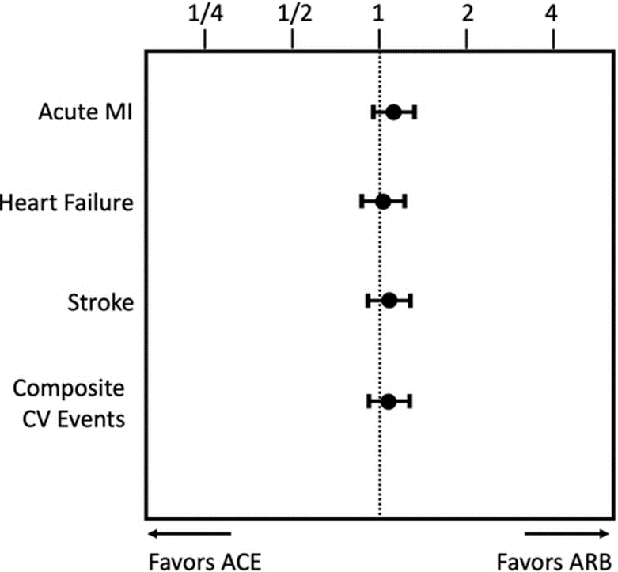

Abstract
ACE (angiotensin-converting enzyme) inhibitors and angiotensin receptor blockers (ARBs) are equally guideline-recommended first-line treatments for hypertension, yet few head-to-head studies exist. We compared the real-world effectiveness and safety of ACE inhibitors versus ARBs in the first-line treatment of hypertension. We implemented a retrospective, new-user comparative cohort design to estimate hazard ratios using techniques to minimize residual confounding and bias, specifically large-scale propensity score adjustment, empirical calibration, and full transparency. We included all patients with hypertension initiating monotherapy with an ACE inhibitor or ARB between 1996 and 2018 across 8 databases from the United States, Germany, and South Korea. The primary outcomes were acute myocardial infarction, heart failure, stroke, and composite cardiovascular events. We also studied 51 secondary and safety outcomes including angioedema, cough, syncope, and electrolyte abnormalities. Across 8 databases, we identified 2 297 881 patients initiating treatment with ACE inhibitors and 673 938 patients with ARBs. We found no statistically significant difference in the primary outcomes of acute myocardial infarction (hazard ratio, 1.11 for ACE versus ARB [95% CI, 0.95–1.32]), heart failure (hazard ratio, 1.03 [0.87–1.24]), stroke (hazard ratio, 1.07 [0.91–1.27]), or composite cardiovascular events (hazard ratio, 1.06 [0.90–1.25]). Across secondary and safety outcomes, patients on ARBs had significantly lower risk of angioedema, cough, pancreatitis, and GI bleeding. In our large-scale, observational network study, ARBs do not differ statistically significantly in effectiveness at the class level compared with ACE inhibitors as first-line treatment for hypertension but present a better safety profile. These findings support preferentially prescribing ARBs over ACE inhibitors when initiating treatment for hypertension.
Should Angiotensin-Converting Enzyme Inhibitors Ever Be Used for the Management of Hypertension?
Jeffrey M. Turner and Ravi Kodali
Curr Cardiol Rep. 2020; 22(9): 95.
Published online 2020 Jul 9. doi: 10.1007/s11886-020-01352-8
https://www.ncbi.nlm.nih.gov/pmc/articles/PMC7344347/

Abstract
Angiotensin-converting enzyme inhibitors and angiotensin receptor blockers are commonly used anti-hypertensive medications in a number of clinical settings. They are often used interchangeably, but we pose the provocative question as to whether they should be. We review the literature to evaluate for any differences in efficacy between the two classes in order to determine if the greater side effects associated with angiotensin-converting enzyme inhibitors are offset by any advantageous effects on outcomes to warrant their use over angiotensin receptor blockers.

Recent Findings:
In many clinical scenarios, the data supports similar efficacy between ACE inhibitors and ARBs, while in a minority of others, there are murky signals from previous trials that suggest ACE inhibitors may be better. However, when reviewing the literature in its entirety, and taking into account recently published pooled analysis and head to head trials, it is reasonable to conclude that ACE inhibitors and ARBs have similar efficacy. This is in contrast to data on adverse effects, which consistently favours the use of ARBs.

Summary:
From the available data, it is reasonable to conclude that ACE inhibitors and ARBs have equal efficacy yet unequal adverse effects. It is in this context that we take the provocative stance that ACE inhibitors should not be used to treat hypertension.

Angiotensin converting enzyme (ACE) inhibitors versus angiotensin receptor blockers for primary hypertension
Cochrane Database Syst Rev. 2014 Aug; 2014(8): CD009096.
Published online 2014 Aug 22. doi: 10.1002/14651858.CD009096.pub2
PMCID: PMC6486121
PMID: 25148386
Edmond CK Li, Balraj S Heran, and James M Wright
https://www.ncbi.nlm.nih.gov/pmc/articles/PMC6486121/

Abstract
Angiotensin converting enzyme inhibitors (ACE inhibitors) and angiotensin receptor blockers (ARBs) are widely prescribed for primary hypertension (systolic blood pressure > 140 mmHg or diastolic blood pressure > 90 mmHg). However, while ACE inhibitors have been shown to reduce mortality and morbidity in placebo‐controlled trials, ARBs have not. Therefore, a comparison of the efficacies of these two drug classes in primary hypertension for preventing total mortality and cardiovascular events is important.

Objectives
To compare the effects of ACE inhibitors and ARBs on total mortality and cardiovascular events, and their rates of withdrawals due to adverse effects (WDAEs), in people with primary hypertension.

Search methods
We searched the Cochrane Hypertension Group Specialized Register, the Cochrane Central Register of Controlled Trials (CENTRAL), MEDLINE, EMBASE, the World Health Organization (WHO) International Clinical Trials Registry Platform, and the ISI Web of Science up to July 2014. We contacted study authors for missing and unpublished information, and also searched the reference lists of relevant reviews for eligible studies.

Selection criteria
We included randomized controlled trials enrolling people with uncontrolled or controlled primary hypertension with or without other risk factors. Included trials must have compared an ACE inhibitor and an ARB in a head‐to‐head manner and lasted for a duration of at least one year. If background blood pressure lowering agents were continued or added during the study, the protocol to do so must have been the same in both study arms.

Data collection and analysis
We used standard methodological procedures expected by The Cochrane Collaboration.

Main results
Nine studies with 11,007 participants were included. Of the included studies, five reported data on total mortality, three reported data on total cardiovascular events, and four reported data on cardiovascular mortality. No study separately reported cardiovascular morbidity. In contrast, eight studies contributed data on WDAE. Included studies were of good to moderate quality. There was no evidence of a difference between ACE inhibitors and ARBs for total mortality (risk ratio (RR) 0.98; 95% confidence interval (CI) 0.88 to 1.10), total cardiovascular events (RR 1.07; 95% CI 0.96 to 1.19), or cardiovascular mortality (RR 0.98; 95% CI 0.85 to 1.13). Conversely, a high level of evidence indicated a slightly lower incidence of WDAE for ARBs as compared with ACE inhibitors (RR 0.83; 95% CI 0.74 to 0.93; absolute risk reduction (ARR) 1.8%, number needed to treat for an additional beneficial outcome (NNTB) 55 over 4.1 years), mainly attributable to a higher incidence of dry cough with ACE inhibitors. The quality of the evidence for mortality and cardiovascular outcomes was limited by possible publication bias, in that several studies were initially eligible for inclusion in this review, but had no extractable data available for the hypertension subgroup. To this end, the evidence for total mortality was judged to be moderate, while the evidence for total cardiovascular events was judged to be low by the GRADE approach.

Authors' conclusions
Our analyses found no evidence of a difference in total mortality or cardiovascular outcomes for ARBs as compared with ACE inhibitors, while ARBs caused slightly fewer WDAEs than ACE inhibitors. Although ACE inhibitors have shown efficacy in these outcomes over placebo, our results cannot be used to extrapolate the same conclusion for ARBs directly, which have not been studied in placebo‐controlled trials for hypertension. Thus, the substitution of an ARB for an ACE inhibitor, while supported by evidence on grounds of tolerability, must be made in consideration of the weaker evidence for the efficacy of ARBs regarding mortality and morbidity outcomes compared with ACE inhibitors. Additionally, our data mostly derives from participants with existing clinical sequelae of hypertension, and it would be useful to have data from asymptomatic people to increase the generalizability of this review. Unpublished subgroup data of hypertensive participants in existing trials comparing ACE inhibitors and ARBs needs to be made available for this purpose.

In conclusion, the above studies show that ARBs exhibit fewer adverse events and have greater tolerability but show no difference in total mortality or cardiovascular outcomes than ACE inhibitors.
ACE Inhibitor Side Effects

Cough
Cough occurs in about 15% of people taking an ACE inhibitor and may occur at any time after starting treatment. If the cough is troublesome (for example it prevents the person from sleeping) and other causes have been ruled out, switching to an angiotensin-II receptor blocker should be considered [NICE, Hypertension in adults 2019].

ARBs do not break down bradykinin and other kinins and are therefore unlikely to cause a persistent dry cough.

Comment: Prescribing an ARB first line over an ACE inhibitor may prevent the need to change to an ARB later if the patient develops a cough or other intolerable side effect. This would also potentially reduce administration and GP time involved in the change and wasted ACE inhibitor medication. Using a medication first line with a reduced occurrence of side effects may also potentially increase patient adherence.

Dose Titration

NICE CKS dose titration recommendations ACE inhibitors
Start with a low dose of angiotensin-converting enzyme (ACE) inhibitor and gradually titrate upwards (usually every 2–4 weeks depending on the drug) until the target blood pressure has been achieved, or until the person has reached the maximum advised or tolerated dose of ACE inhibitor.

NICE CKS dose titration recommendations ARB
Start with a low dose of angiotensin-II receptor blocker (ARB) and titrate upwards every 4 weeks until the target blood pressure has been achieved, or the person has reached the maximum prescribable or tolerated dose of ARB.

Tables 1. and 2. below highlight that there are generally fewer titration steps required between the usual starting dose and usual maintenance doses for ARBs compared to ACE inhibitors.

Comment: Titration steps maybe reduced if an ARB is prescribed over an ACE inhibitor, which may also reduce administration and GP time.

Angiotensin II receptor blockers
Doses from NICE CKS last revised April 2021. Accessed March 2022. Angiotensin-II receptor blockers | Prescribing information | Hypertension | CKS | NICE
Prices based on August 2022 Drug Tariff. Cost for 28 days treatment.
Table 1.
ARB | Low starting doses* | Usual starting dose | Usual maintenance dose | Maximum dose
Azilsartan | 20 to 40 mg once a day | 40 mg once a day | 40 to 80 mg once a day | 80 mg once a day
Price | £16.80 | £16.80 | £16.80 - £19.95 | £19.95
Candesartan | 4 mg once a day | 8 mg once a day | 8 mg once a day | 32 mg once a day
Price | £2.44 | £1.01 | £1.01 | £1.42
Eprosartan | 600 mg once a day | 600 mg once a day | 600 mg once a day | 600 mg once a day
Price | £14.31 | £14.31 | £14.31 | £14.31
Irbesartan | 75 mg once a day | 150 mg once a day | 150 mg once a day | 300 mg once a day
Price | £1.14 | £1.52 | £1.52 | £2.15
Losartan | 25 mg once a day | 50 mg once a day | 50 mg once a day | 100 mg once a day
Price | £2.23(Aug 22)  £0.91(March 22) | £3.13 (Aug 22)  £1.04 (March 22) | £3.13 (Aug 22)  £1.04(March 22) | £4.04 (Aug 22)  £1.20(March 22
Olmesartan | 10 mg once a day | 10 mg once a day | 20 mg once a day | 40 mg once a day
Price | £2.59 | £2.59 | £5.04 | £3.58
Telmisartan | 20 mg once a day | 20 to 40 mg once a day | 40 mg once a day | 80 mg once a day
Price | £1.21 | £1.21-£1.42 | £1.42 | £1.68
Valsartan | 40 mg once a day | 80 mg once a day | 80 to 160 mg once a day | 320 mg once a day
Price (capsule prices, tablets more expensive) | £2.82 | £4.52 | £4.52-£7.27 | £14.54  (2 x 160mg)
* Lower starting doses are required for people who are more prone to the adverse effects of ARBs (such as elderly, frail, or renally impaired people or people who are taking a diuretic).

Candesartan is currently the lowest cost ARB of all the ARBs used to treat hypertension.
At the initial stages of writing this paper (March 2022), losartan was proposed as the first line ARB of choice. However, the price of losartan increased quite significantly in the July 2022 drug tariff which led the authors to consider alternative first line ARBs.
Both the March 22 and August 22 prices have been included to show the Losartan price increase, it is not known when the price of Losartan will drop back to March 2022 values.
The committee is being asked to consider candesartan as another potential 1st line ARB as it is currently the lowest cost ARB of all the ARBs used to treat hypertension.

ACE Inhibitors
For comparison, the Surrey Heartlands CCG recommended first line ACE inhibitor prices.
Doses from NICE CKS last revised last revised April 2021. Accessed March 2022.
Angiotensin-converting enzyme inhibitors | Prescribing information | Hypertension | CKS | NICE
Prices based on August 2022 Drug Tariff. Cost for 28 days treatment
Table 2.
ACE inhibitor | Low starting doses* | Usual starting dose | Usual maintenance dose | Maximum dose
Lisinopril | 2.5 mg once a day | 10 mg once a day | 20 mg once a day | 80 mg once a day
Cost | £0.77 | £0.83 | £0.99 | £3.96
Ramipril | 1.25 mg once a day | 1.25 to 2.5 mg once a day | 2.5 mg to 10 mg once a day | 10 mg once a day
Cost (lowest cost for each dose either capsule or tablet) | £0.95 | £0.95 - £0.96 | £0.96 - £1.07 | £1.07
*Lower starting doses are required for people who are more prone to the adverse effects of ACE inhibitors (such as elderly, frail, or renally impaired people, or people on low-dose diuretics).

Costs

Tables 1. and 2. above highlight the costs for the ARBs and commonly prescribed ACE inhibitors for the different doses.

It shows that many of the ARBs are now comparable in price to the ACE inhibitors.

NICE recommends that a once daily generic drug that minimises costs should be prescribed.

At the time of initially writing this paper March 2022 losartan was the ARB with the lowest drug tariff price for hypertension starting, maintenance and maximum doses. Losartan is also once daily and available generically. Losartan costs were comparable to ramipril.

However, the drug tariff price increased for losartan quite significantly in July 2022 and remains at the same level for August 2022. The exact reason for this is not known but the recent MHRA recall of losartan and irbesartan batches over contaminant concerns (see MHRA recall June 2021) may have played a deciding factor.

Candesartan is currently the lowest cost ARB for usual starting, maintenance, and maximum doses for hypertension.

Losartan was initially proposed as the 1st line ARB of choice, however due to its recent price increase, the committee is also asked to consider candesartan as a potential first line ARB. Candesartan is currently the lowest cost ARB for usual starting, maintenance, and maximum doses for hypertension.

See Appendix 1 for comparative prescribing data of Losartan, Candesartan and Ramipril in Surrey Heartlands against other systems.

Appointment costs
The Kings Fund: A recent study estimated that, in 2020, the average 9-minute GP consultation costs £39.23.
Key facts and figures about the NHS | The King's Fund (kingsfund.org.uk)

U&E Blood costs
£8.45 from ICE July 22

Comment: Using the lowest cost ARB will enable more patients to be treated within the allocated resources. The appointment and blood costs associated with up titration of an ACE inhibitor or switching to an ARB when an ACE inhibitor has not been tolerated maybe reduced by using an ARB first line.

Choice of ARB

Angiotensin-II receptor blockers | Prescribing information | Hypertension | CKS | NICE
NICE CKS recommends that the choice of angiotensin-II receptor blocker usually depends on the person's co-morbidities, local recommendations, and cost. Where possible the ARB should be a once daily generic drug that minimises costs.
- For people with heart failure and hypertension, candesartan, losartan, and valsartan may be preferred.
- For people who have diabetes and hypertension, candesartan, irbesartan, losartan, or valsartan may be preferred.

Losartan SPC Losartan Potassium 50 mg Film-coated Tablets - Summary of Product Characteristics (SmPC) - (emc) (medicines.org.uk) . Accessed 24/3/2022
The licensed indications for losartan include:
- Treatment of essential hypertension in adults and in children and adolescents 6-18 years of age.
- Treatment of renal disease in adult patients with hypertension and type 2 diabetes mellitus with proteinuria ≥0.5 g/day as part of an antihypertensive treatment
- Treatment of chronic heart failure in adult patients when treatment with Angiotensin converting enzyme (ACE) inhibitors is not considered suitable due to incompatibility, especially cough, or contraindication. Patients with heart failure who have been stabilised with an ACE inhibitor should not be switched to losartan. The patients should have a left ventricular ejection fraction ≤ 40% and should be clinically stable and on an established treatment regimen for chronic heart failure
- Reduction in the risk of stroke in adult hypertensive patients with left ventricular hypertrophy documented by ECG (see section 5.1 LIFE study, Race).

The losartan SPC states that the usual starting and maintenance dose is 50 mg once daily for most patients. The maximal antihypertensive effect is attained 3-6 weeks after initiation of therapy. Some patients may receive an additional benefit by increasing the dose to 100 mg once daily (in the morning).

Candesartan SPC Candesartan cilexetil 8mg tablets - Summary of Product Characteristics (SmPC) - (emc) (medicines.org.uk). Accessed 3/8/22
The licensed indications for candesartan include:
• Treatment of primary hypertension in adults.
• Treatment of hypertension in children and adolescents aged 6 to <18 years.
• The treatment of adult patients with heart failure and impaired left ventricular systolic function (left ventricular ejection fraction ≤ 40%) when Angiotensin Converting Enzyme (ACE)-inhibitors are not tolerated or as add-on therapy to ACE-inhibitors in patients with symptomatic heart failure, despite optimal therapy, when mineralocorticoid receptor antagonists are not tolerated.

The recommended initial dose and usual maintenance dose of Candesartan Cilexetil is 8 mg once daily. Most of the antihypertensive effect is attained within 4 weeks. In some patients whose blood pressure is not adequately controlled, the dose can be increased to 16 mg once daily and to a maximum of 32 mg once daily. Therapy should be adjusted according to blood pressure response.

Black patients
The antihypertensive effect of candesartan is less pronounced in Black patients than in non-Black patients. Consequently, uptitration of candesartan cilexetil and concomitant therapy may be more frequently needed for blood pressure control in Black patients than in non-Black patients

Comment: Candesartan and losartan would cover the most co morbidities as per NICE CKS. Losartan is the ARB which has the most licensed indications.
Within Surrey Heartlands there are almost 3 times the number of losartan items prescribed than candesartan which can be seen in appendix 1.
Ideally if current costs of losartan had not increased, losartan would be the recommended first line ARB.

Precedent Setting

Looking at other CCG’s current recommendations, North Yorkshire and Vale of York CCG’s and West Yorkshire and Harrogate CCG recommend losartan 50mg once daily over an ACE inhibitor in their uncomplicated hypertension (under 80 years old and no diabetes / CKD 3B+ / Heart Failure / IHD / CVA/PAD) guidelines for stage 1, 2 and 3 hypertensive patients not controlled by amlodipine and indapamide.
Healthy_Hearts_Hypertension_guidance_updated.01.pdf (northyorkshireccg.nhs.uk)
WYH Healthy Hearts Hypertension Clinical Searches.pdf (westyorkshireandharrogatehealthyhearts.co.uk)

There are CCG’s who recommend candesartan 1st line or as an alternative to losartan when an ARB is indicated.

Summary

NICE Hypertension in adult’s guideline and NICE Chronic kidney disease guideline both now give equal status of choice in their treatment pathways for an ACE inhibitor and an ARB. Evidence from research and reviews of clinical literature has mainly shown that effectiveness of ACE inhibitors and ARBs are similar, but ARBs show a better safety and tolerability profile.

Below summarises the potential benefits and disadvantages of recommending an ARB first line within our local hypertension guidelines.

Potential Benefits
- Fewer clinician appointments required for switching an ACE inhibitor to an ARB (if ACE inhibitor not tolerated)
- Decreased drug waste due to potential switching from ACE inhibitor to ARB
- Decreased administration time involved in changing from an ACE inhibitor to an ARB (including resource expenditure on associated blood testing)
- Fewer titration steps (which would involve GP and administration time) to maximum dose for the ARB losartan than current first line preferred RAAS inhibitor, ramipril. Ref CKS NICE Hypertension
- All ARBs are now available generically (apart from azilsartan) and have subsequently decreased in price. Some ARBs are similarly priced to the ACE inhibitor, ramipril, which is currently the first line RAAS inhibitor in Surrey Heartlands.
- When indicated an ARB is the recommended choice over an ACE inhibitor for adults of Black African or African–Caribbean family origin
- Some systems are starting to recommend an ARB over an ACE inhibitor.
- Increased patient adherence to therapy due to the potential avoidance of an ACE related cough and the requirement to change treatment.

Potential Disadvantages
- Slight change in current clinical practice
- This recommendation does not apply to all patient cohorts e.g., those diagnosed with heart failure or post MI patients.

Choice of ARB
The 2014 Hypertension Treatment Guideline on the Surrey PAD, currently recommends losartan, candesartan and irbesartan if an ARB is indicated.
Hypertension Treatment Options - Guidelines -PCN April 2014.pdf (res-systems.net)

Losartan has a wide range of licensed indications and recommended by NICE CKS for patients with diabetes and hypertension and patients who have heart failure and hypertension. It is available as a once daily generic drug, and it was previously the lowest cost ARB.

Candesartan is also recommended by NICE CKS for patients with diabetes and hypertension and patients who have heart failure and hypertension. It is available as a once daily generic drug and is currently the lowest cost ARB.

Losartan was initially proposed as the 1st line ARB of choice, however due to its recent price increase, the committee is also asked to consider candesartan as a potential first line ARB.

This paper is for new initiations only.

The committee is asked to agree:

- Recommending an ARB over an ACE where they have been given equal status of choice for treating hypertension in adults.
- Agree on the first line ARB for treating hypertension in adults to be either:
- losartan or
- candesartan or
- a choice of either losartan or candesartan.

Appendix 1

Comparative prescribing data of Losartan, Candesartan and Ramipril in Surrey Heartlands against other systems. Ref Open prescribing (accessed Aug 2022)

Losartan
https://openprescribing.net/analyse/#org=CCG&orgIds=92A&numIds=0205052N0AA&denomIds=2.5&selectedTab=summary

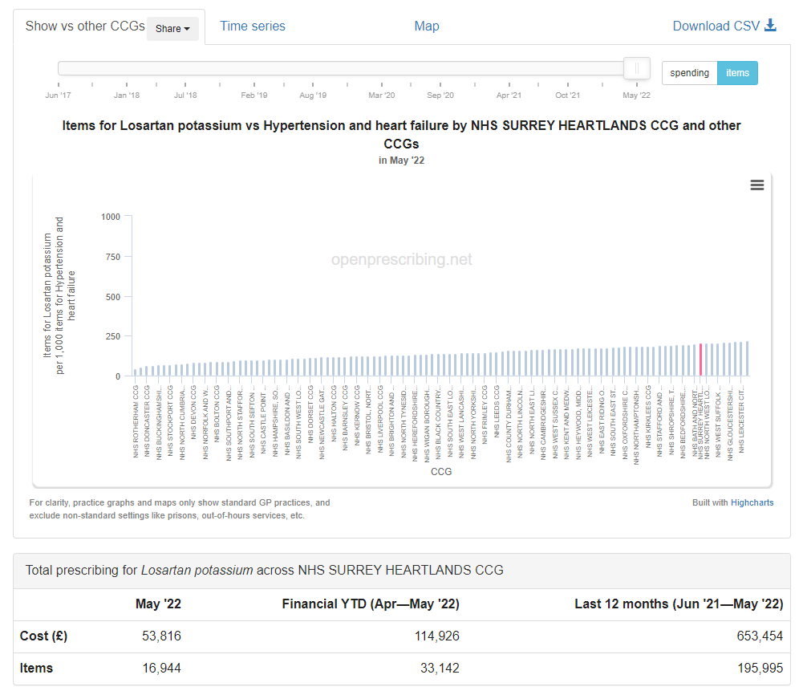

Candesartan https://openprescribing.net/analyse/#org=CCG&orgIds=92A&numIds=0205052C0AA&denomIds=2.5&selectedTab=summary

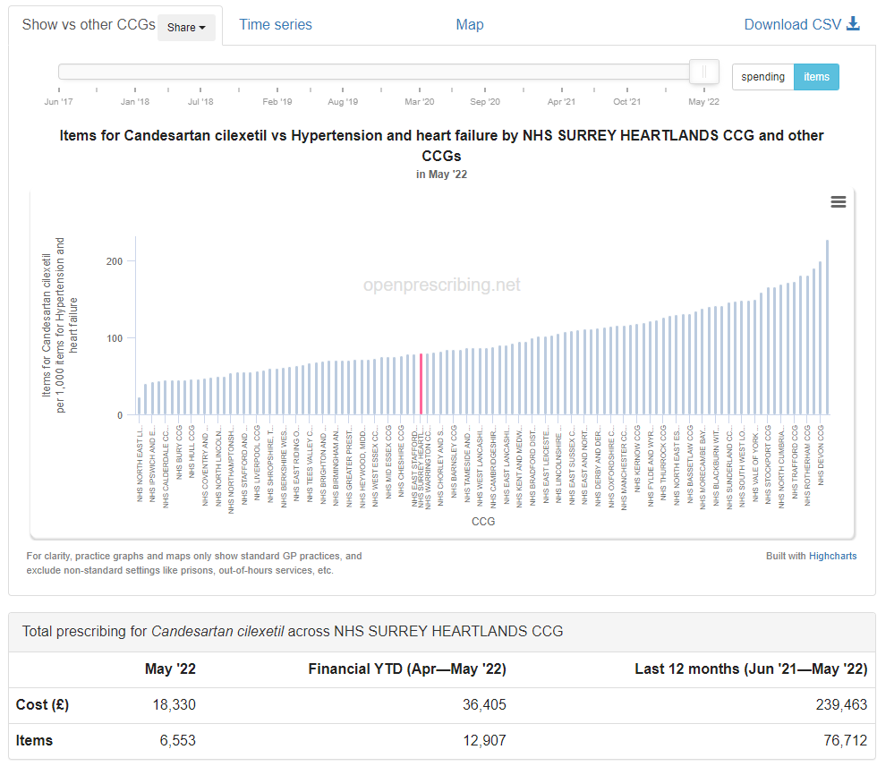

Ramipril https://openprescribing.net/analyse/#org=CCG&orgIds=92A&numIds=0205051R0AA&denomIds=2.5&selectedTab=summary

